ADVANCED ASSIGNMENT #4
SHIVA KARTHIK REDDY KOYYA

FLOW CHART OF THE SYSTEM
CODE

creating circular obstacles and plotting in theta space 1
trajectory in theta space 3
trajectory in cartesian space 3
getting the characterstics equation describing the position velocity and accleration of each joint 4
clc;
clear all;
close all;

creating circular obstacles and plotting in theta space
% circ1e 1
[c1, c2,c1_b,c2_b]=circle(-1.625,-0.3,0.25);
PLOT_theta(c1,c2,30,-110,180,0);
PLOT_theta(c1_b,c2_b,30,-110,180,0);
PLOT_theta(c1+360,c2,30,-110,180,0);
PLOT_theta(c1_b+360,c2_b,30,-110,180,0);
%circle 2
[c3, c4,c3_b,c4_b]=circle(0.75,0,0.125);
PLOT_theta(c3,c4,30,-110,180,0);
PLOT_theta(c3_b,c4_b,30,-110,180,0);
PLOT_theta(c3+360,c4,30,-110,180,0);
PLOT_theta(c3_b+360,c4_b,30,-110,180,0);
%circle 3
[c5, c6,c5_b,c6_b]=circle(1.125,0,0.125);
PLOT_theta(c5,c6,30,-110,180,0);
PLOT_theta(c5_b,c6_b,30,-110,180,0);
PLOT_theta(c5,c6,30,-110,180,0);
PLOT_theta(c5_b,c6_b,30,-110,180,0);
square(-1.25,0.625,0.4);
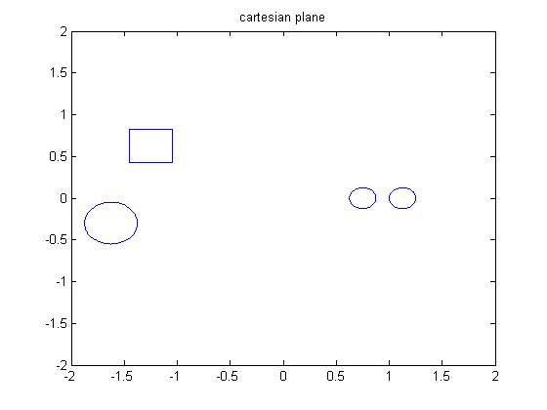
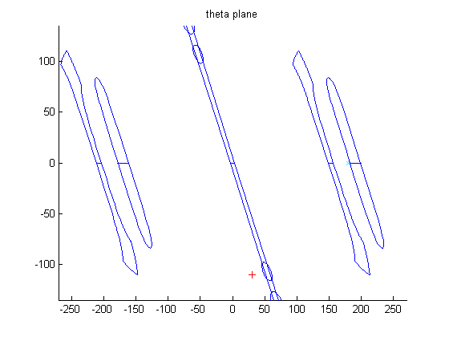

trajectory in theta space
figure(2)
axis([-270 270 -135 135])
hold on
x=[30 65 230];
y=[ -110 -121 -123 ];
hold on
x1=[180 200 230];
y1=[ 0 -55 -123 ];
cs=spline(x, y );
cs1=spline (x1,y1);
xx= linspace(30,230,101);
xx1= linspace (180,230,101);
plot(x,y,'o',xx,ppval(cs,xx),'-');
hold on
plot(x1,y1,'o',xx1,ppval(cs1,xx1),'-');
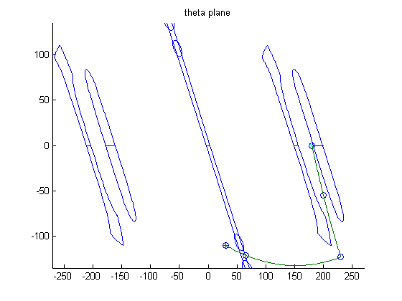

trajectory in Cartesian space
robot();
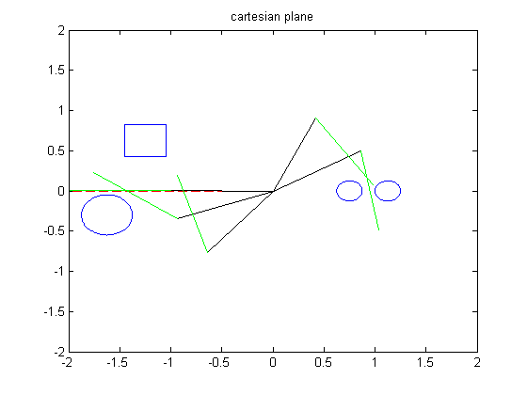

Getting the characteristics equation describing the position velocity and acceleration of each joint
theta1_i=30;
theta1_f= 180;
vel1_i=0;
vel1_f=0;
acc1_f=0;
acc1_i=0;
t_i=0;
t_f=4;
time= t_i:t_f;
theta2_i=-110;
theta2_f=0;
vel2_i=0;
vel2_f=0;
acc2_f=0;
acc2_i=0;
k1=[theta1_i theta1_f vel1_i vel1_f acc1_i acc1_f]';
mat=[1 t_i t_i^2 t_i^3 t_i^4 t_i^5 ;...
1 t_f t_f^2 t_f^3 t_f^4 t_f^5 ;...
0 1 2*t_i 3*t_i^2 4*t_i^3 5*t_i^4;...
0 1 2*t_f 3*t_f^2 4*t_f^3 5*t_f^4;...
0 0 2 6*t_i 12*t_i^2 20*t_i^3;...
0 0 2 6*t_f 12*t_f^2 20*t_f^3];
coff1=(mat)\k1;
k2=[theta2_i theta2_f vel2_i vel2_f acc2_i acc2_f]';
mat=[1 t_i t_i^2 t_i^3 t_i^4 t_i^5 ;...
1 t_f t_f^2 t_f^3 t_f^4 t_f^5 ;...
0 1 2*t_i 3*t_i^2 4*t_i^3 5*t_i^4;...
0 1 2*t_f 3*t_f^2 4*t_f^3 5*t_f^4;...
0 0 2 6*t_i 12*t_i^2 20*t_i^3;...
0 0 2 6*t_f 12*t_f^2 20*t_f^3];
coff2=(mat)\k2;
r=fliplr(coff1');
coff1=r';
q=fliplr(coff2');
coff2=q';
% position, velocity and accleration equations
syms t;
theta1=poly2sym(coff1,t);
theta2=poly2sym(coff2,t);
vel1=diff(theta1);
vel2=diff(theta2);
acc1=diff(vel1);
acc2=diff(vel2);
t1=zeros(1,5);
t2=zeros(1,5);
v1=zeros(1,5);
v2=zeros(1,5);
a1=zeros(1,5);
a2=zeros(1,5);
for i=1:length(time)
t=time(i);
t1(i)=subs(theta1);
t2(i)=subs(theta2);
v1(i)=subs(vel1);
v2(i)=subs(vel2);
a1(i)=subs(acc1);
a2(i)=subs(acc2);
end
figure(3)
title('postion velocity acclerartion profiles')
subplot(3,1,1)
plot(time,t1,'r')
hold on
plot(time,t2,'g')
legend('joint1','joint2')
subplot(3,1,2)
plot(time,v1,'r')
hold on
plot(time,v2,'g')
subplot(3,1,3)
plot(time,a1,'r')
hold on
plot(time,a2,'g')
disp ('position equation for joint 1')
disp(theta1)
disp ('position equation for joint 2')
disp(theta2)
disp ('velocity equation for joint 1')
disp(vel1)
disp ('velocity equation for joint 2')
disp(vel2)
disp (' accleration equation for joint 1')
disp(acc1)
disp ('accleration equation for joint 2')
disp(acc2)
position equation for joint 1
(225*t^5)/256 - (1125*t^4)/128 + (375*t^3)/16 + 30
position equation for joint 2
(165*t^5)/256 - (825*t^4)/128 + (275*t^3)/16 - 110
velocity equation for joint 1
(1125*t^4)/256 - (1125*t^3)/32 + (1125*t^2)/16
velocity equation for joint 2
(825*t^4)/256 - (825*t^3)/32 + (825*t^2)/16
accleration equation for joint 1
(1125*t^3)/64 - (3375*t^2)/32 + (1125*t)/8
accleration equation for joint 2
(825*t^3)/64 - (2475*t^2)/32 + (825*t)/8
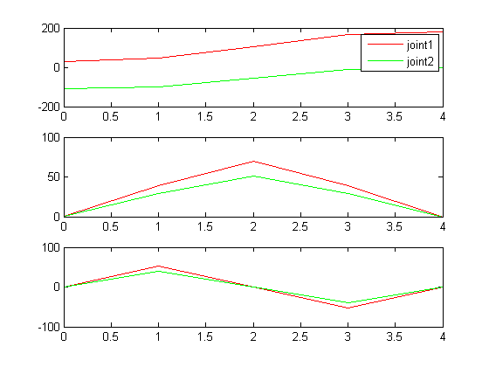
Published with MATLAB® R2012b

